Adding to AFSLReferences

Ward Handley

9/16/2015

# Motivation

A comprehensive summary and citation document (AFSLReferences) assists AFSL researchers by leveraging relevant work by other experts in the field. This document is particularly valuable as a citation manager when generating posters for conferences or papers for journal publication.

# How-to

1. In Perforce navigate to \\AFSL\TechnicalDataPackage\Word\
   1. checkout and lock both AFSLReferences.doc and AFSLReferences.xml
2. Open AFSLReferences.doc
3. Link AFSLReferences.doc to AFSLReferences.xml
   1. References tab >> Manage Sources >> Browse >> select AFSLReferences.xml



* 1. The list of sources on the left hand side should populate with all the references AFSL researchers have cited

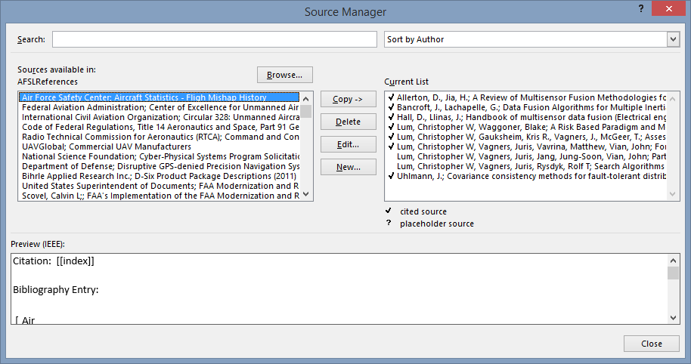

1. Add your new reference by clicking “New…”

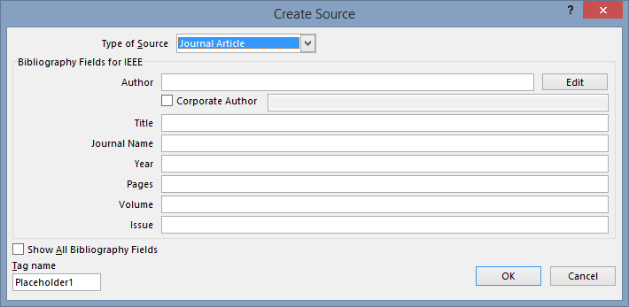

* 1. Select the appropriate type of source
  2. Add multiple authors by clicking “Edit” to the right of the Author field
     1. Make sure your authors are in the correct order!

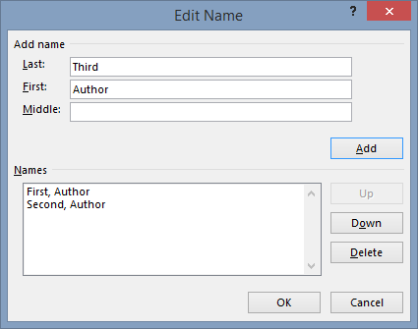

1. Copy and paste your summary and/or notes under the appropriate topic heading
   1. Choose an appropriate title for your reference at the Heading 2 level (Home tab >> Styles >> Heading 2)
   2. Headings can conveniently be expanded or collapsed to declutter the document

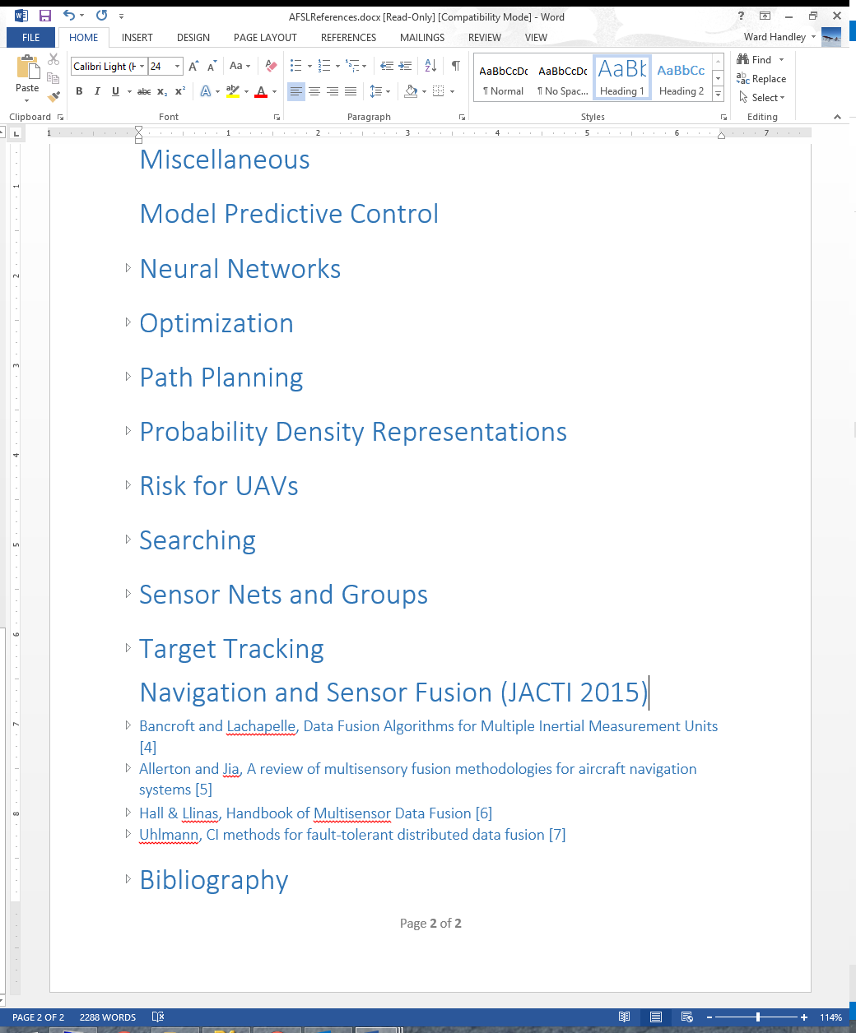

1. Save and check both AFSLReferences.docx and AFSLReferences.xml in to Perforce